THE PLASMACOAT
A GUIDE
Professor Des Gibson

Table of Contents

 | Introduction | 3
1. | DC magnetron Sputtering in Brief | 3
2. | The PlasmaCoat | 4
3. | Loading The PlasmaCoat | 7
4. | Determining The Deposition Rate | 9
5. | Creating A Material Model | 12
6. | Designing A Film | 13
7. | Tooling Factor | 15
8. | Arcing | 18
9. | Summary | 19
10. | References | 20
 | APPENDIX A | 21
 | APPENDIX B | 22

The PlasmaCoat
The PlasmaCoat is a DC magnetron sputtering apparatus used for the deposition of multilayer thin film optical coatings also often referred to as optical filters which are of crucial importance for a large number of important applications, from optics to sensors and even to nuclear fusion where inertial confinement by high power lasers depends critically on large area dielectric mirrors [1].

- DC Magnetron Sputtering in Brief
DC magnetron sputtering is a Physical Vapour Deposition (PVD) technique and its operation is as follows; the sputter deposition chamber consists of; the chamber walls, target materials, a substrate, an inert gas plasma and a plasma source for reactive sputtering. The target material is held at a negative potential (cathode) and the substrate is maintained at a positive potential (anode). When the potential difference between the target and the substrate is sufficiently high the energy in the resulting electric field causes the inert gas (for the PlasmaCoat, argon) to ionise, forming a plasma of positively charged argon ions and negatively charged electrons. The argon ions are thus accelerated toward and bombard the cathodic metal target, ejecting metal target particles via kinetic transfer of momentum causing them to enter the vapour phase. The ejected target particle’s momentum and kinetic energy carries it toward the substrate, upon which it condenses and is deposited in thin film form. In reactive sputtering, an additional reactive gas can be introduced such that the target particle interacts with a gas atom or molecule during its trajectory towards the substrate resulting in a metal oxide layer to be deposited on the substrate.
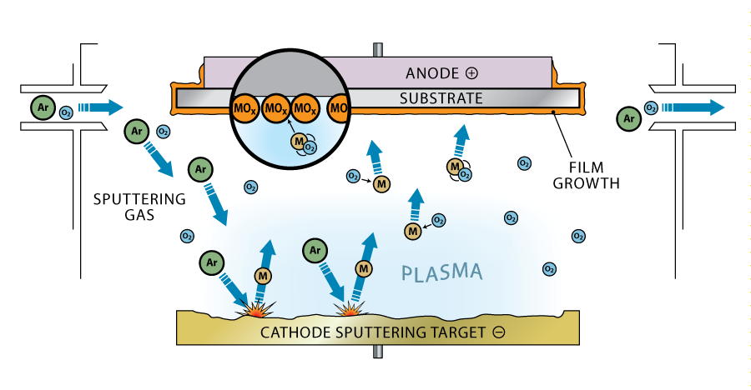
Fig.1 - Inside a sputter deposition chamber. Here, some metal M is ejected from the target via Ar⁺ ions and reacts with O₂ molecules to form a metallic oxide MO_{x} on the substrate surface. [2]

Underneath the target material resides a magnetron, the purpose of which is to magnetically confine the plasma. Electrons are released from the target during its bombardment with ions. These electrons are confined close to the target due to the magnetic field, resulting in further ionisations in the plasma, therefore a higher degree of ionisation or electron density, having the net effect of increasing deposition rate and reducing substrate heating. A typical set up is depicted in figure 2. The confined electrons may erode a pattern in the target material due to the magnetic field, in the PlasmaCoat this pattern is seen as a characteristic ‘racetrack’ as shown in figure 3.

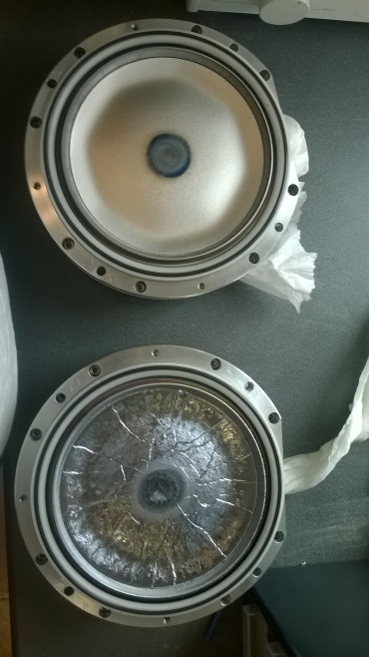
target
magnets
Fig.2 - Typical magnetron set-up Fig.3 – Zr & Si metal targets

Compared with conventional PVD techniques, DC magnetron sputtering has a number of advantages. Due to the high kinetic energies of the sputtered particles (10 times more than evaporated species) the resulting films are a lot harder and more adherent. The high energetic process also removes the need for substrate heating, allowing for depositions on materials that cannot withstand high temperatures [3].

- The PlasmaCoat
The above was a brief description of DC magnetron sputtering in general. The specific set-up for the PlasmaCoat system will now be explored. The PlasmaCoat was designed for small batch high throughput production and uses a patented reactive magnetron sputtering process resulting in the production of dense optical coatings with outstanding durability for the manufacture of single or multilayer thin film filters. The target materials used in the PlasmaCoat are typically silicon and zirconium for the deposition of silica (SiO₂) and zirconia (ZrO₂) although other target materials can be used. Silica and zirconia are optimal for precision optics applications.
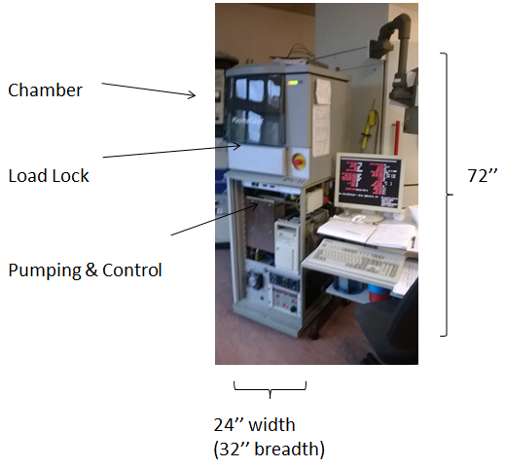

Fig.4 – The PlasmaCoat with chamber covered

Figure 5 provides a schematic representation of the inside of the PlasmaCoat’s sputtering chamber from a Birdseye view. The sputtering argon plasma resides in front of the metal targets and coats the entire chamber, including substrate, with sputtered metal. Each target has its own magnetron and will only get sputtered if that targets magnetron is on. The rotating carousel continually rotates at 100 rpm and as it does so, it passes through the oxygen plasma emitted via the plasma source. The sputtered material on the substrate becomes oxidised, forming a metal oxide film. The magnetrons can be switched on alternately such that at one time, silicon, for example, will be sputtered and then zirconium. A similar thing can be done with the oxygen plasma to produce oxides or just pure metal films.
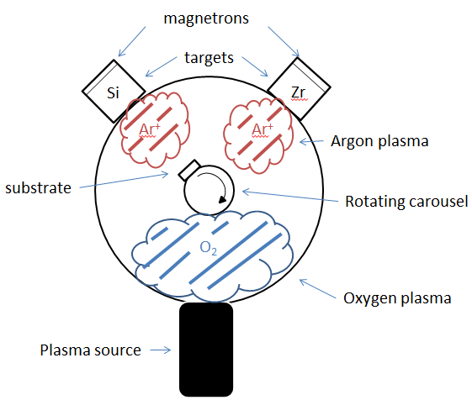

Fig. 5 – Schematic representation of PlasmaCoat’s sputtering chamber (Birdseye view)

Here it should be mentioned that the Plasmacoat system was never intended by the manufacturer to be used for coatings of more than around six layers (as used in ophthalmic applications).

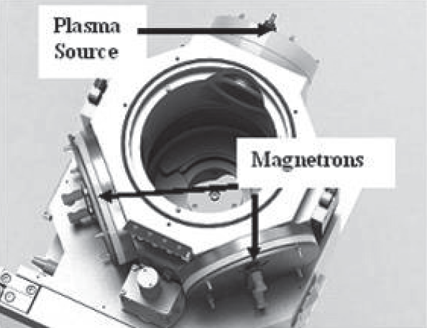
Fig. 6 – Inside the PlasmaCoat chamber

- Loading the PlasmaCoat
The first step to depositing a film on the PlasmaCoat is to load the substrate onto the rotating carousel. In previous work, fused silica substrates have been used. To ensure the best quality films deposited, one must first clean the substrate by hand or preferably in an ultrasonic bath such as the one shown in figure 7. This uses ultrasonic vibrations to help remove particulate contaminants such as organic matter.

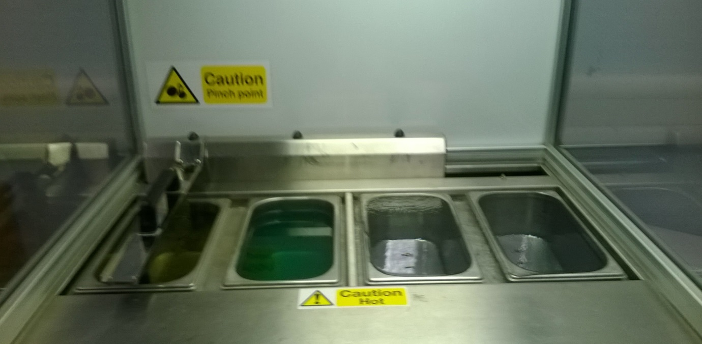
Fig.7 - 4 stage ‘Optimal’ substrate bath; ultrasonic, lye, post clean and drainage

Next, the substrate is fitted into the holder, which slots into the rotating carousel as shown in figure 8. The rotating carousel is mounted into the load lock chamber. From there, the load lock chamber is shut and the start button is pressed for the initial stages of the deposition process to begin. The load lock allows the actual deposition chamber to remain under vacuum even when the machine is not in use. The load lock chamber will drop to deposition chamber vacuum level and the carousel is then automatically raised up into the deposition chamber for the sputter deposition process to begin. Before every deposition, a target clean run must be performed as atmospheric oxygen can slowly oxidise the targets, resulting in an oxide layer and unwanted arcing during deposition which will be discussed later. The target clean bombards both targets with argon ions alternately to remove any oxide layers.

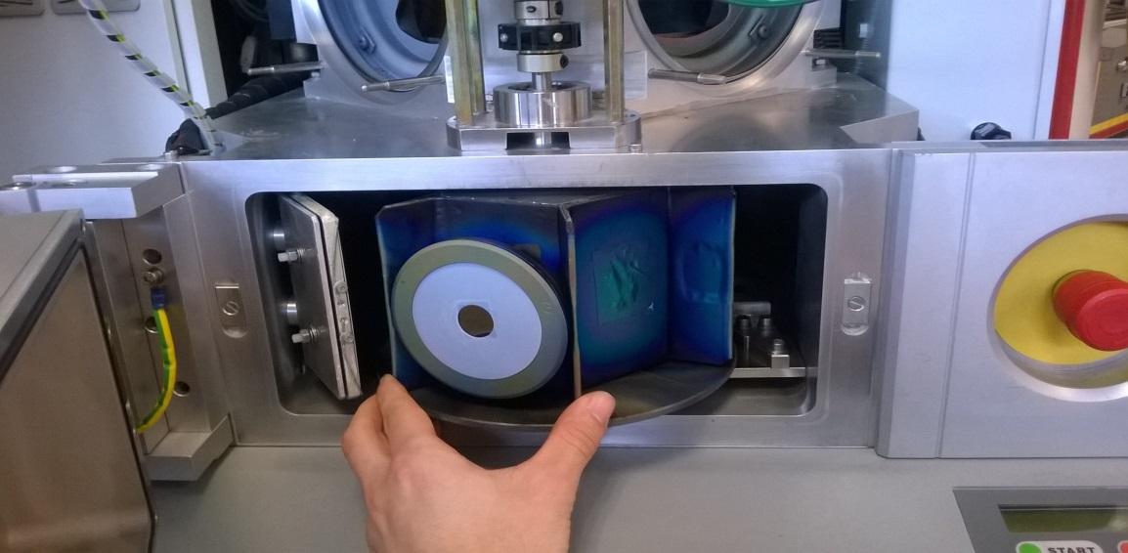
Holder
Carousel
Substrate (Fused Si)

Fig.8 – Substrate in holder, slotted into the carousel and loaded into the load lock chamber

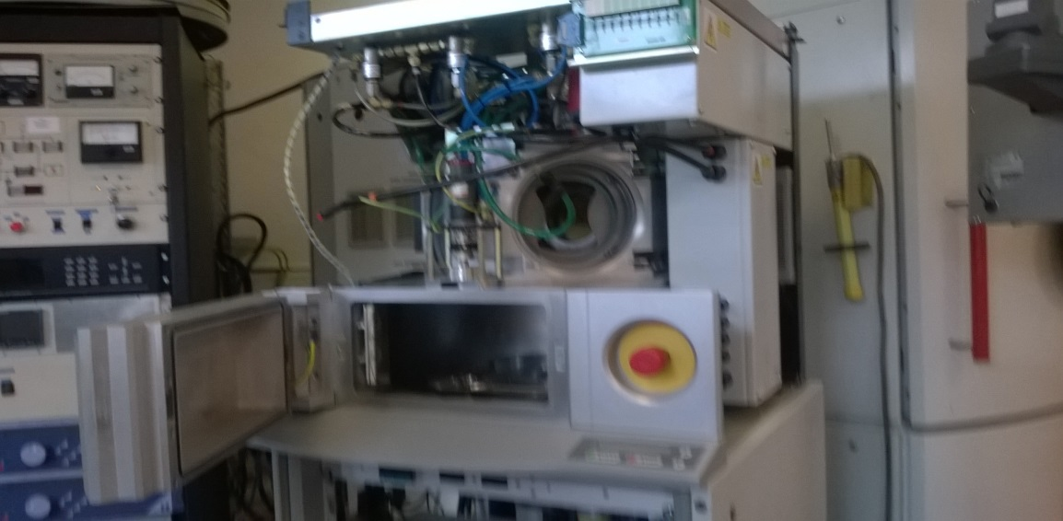

Fig.9 – PlasmaCoat with load lock chamber open and front covering off. One of the targets slots into the circular region above the load lock.

- Determining The Deposition rate
Due to target erosion, the distance between the surface of the target and the substrate eventually changes. This results in a changing deposition rate throughout prolonged use of the PlasmaCoat. Every so often, when beginning a deposition, a new user must determine the most up-to-date deposition rate that the PlasmaCoat is operating in, and the deposition rates can vary between targets. The procedure is simple; the user will choose a known deposition time for the substance for which we want to determine the deposition rate. The thickness of this layer will be measured and the rate can then be calculated by dividing the found thickness by the chosen deposition time. For silicon and zirconium targets the deposition rates for pure Si, pure Zr, SiO₂ and ZrO₂ can be determined if one uses oxygen as the reactive plasma for the compound materials. The PlasmaCoat uses the Macleoud program on a DOS operating system and has a command line interface (CLI).

Step One
We can vary 5 parameters in the deposition for each individual layer; the power supplied to the magnetron [W], the power supplied to the plasma source [W], the rate of argon flow into the chamber [sccm⁻¹], the rate of oxygen flow [sccm⁻¹] and the deposition time [s]. The chosen parameters are put onto a text file and then saved onto a floppy disk as shown in figure 10. The floppy disk is then to be inserted into the PlasmaCoat. Varying these parameters will affect the properties of the film deposited, for example, increasing the oxygen flow will produce a film with a more oxygenated stoichiometric composition or increasing the magnetron power may increase deposition rate due to the presence of more ions.

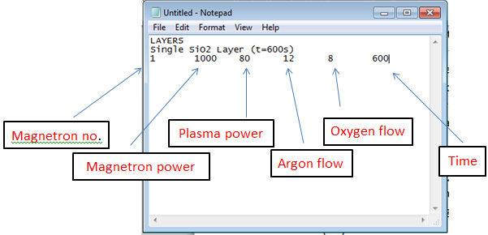

Fig.10 – PlasmaCoat parameters
Step Two
The notepad file must then be programmed into the PlasmaCoat. Once the floppy disk has been inserted, the user must hit end on the keyboard to exit the system status screen then type exit. The following will show up on the screen (the user must type the text shown in black);
C:\CPP\MACLEOD\CPP\X4FINAL>copy a:players.dat
Overwrite C:PLAYERS.DAT (Yes/No/All)? y
1 file(s) copied
C:\CPP\MACLEOD\CPP\X4FINAL>obj\x4
And hit enter. To bring up the system status screen again, the user can type mon. Next the start button on the PlasmaCoat is pressed allowing the user to cycle through the list of possible depositions that have been programmed in – once the selection is chosen the start button is pressed again to begin the deposition. The example shown in figure 10 will deposit a SiO₂ layer for 600 seconds (10 minutes).

Step Three
Once the deposition is complete, one must measure the thickness of the sample. This can be done using a number of methods but the technique used in previous work was optical spectroscopy, done on the Aquila nkd-8000 spectrophotometer. This spectrophotometer has a spectral range of 350-1700nm and has a spectral resolution of 1nm. It uses a 100W tungsten halogen lamp feeding light into a fibre-optic to produce the spectral range and can simultaneously measure Reflectance and Transmittance from the same spot on the sample. There is a hole in the platform, allowing for a transmitted beam to be picked up by the transmittance detector and the reflected beam to be picked up by the reflectance detector opposite the beam tube. The use of the spectrophotometer is necessary at early stages of filter design, as the R & T profiles of single layers can be fitted by the built-in Pro-Optix software, using various fitting models such as the Drude-Lorentz, Powell or LM methods. These fits provides the material’s refractive index N and extinction coefficient K as a function of wavelength, and the layer thickness produced in a given time, essential information required for optical filter design. With the thickness now measured one can calculate the deposition rate using the known time, for example, if in 600 seconds a thickness of 322.058 nanometers was deposited then the deposition rate is;
This information is important for subsequent controlled depositions and the process can be repeated for all possible materials.

- Creating A Material Model
Once the film has been deposited and analysed the resulting Reflectance/Transmittance vs. wavelength curve can be fitted to obtain thickness independent optical constants; refractive index N and extinction coefficient K as a function of wavelength. These raw data can be saved onto a text file and imported into a thin film design software to create a new material model. This is done to ensure that the design program has the most up-to-date information on what the PlasmaCoat is actually depositing and means that the design the programme will produce a more accurate theoretical prediction.
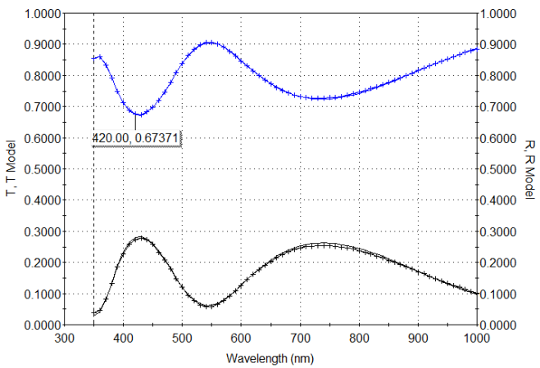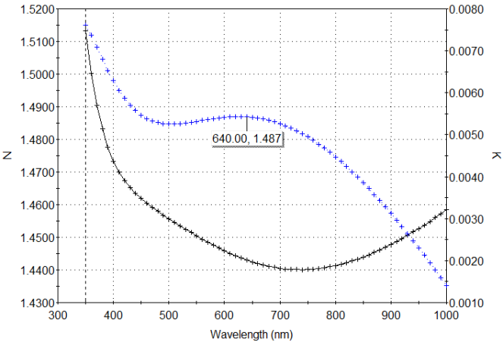
Fig.11 – left: measured R&T for SiO₂ layer. Right N&K data from fit

- Designing A Multilayer Film
There are a number of thin film design programs suitable for designing filters with desired optical profiles, however the software used in previous work with the PlasmaCoat was TFCalc. In TFCalc, the user can define an unlimited number of materials, whose specifications such as; reflection, transmission and extinction coefficients and refractive indices as function of wavelength, can be input into the TFCalc database defining a specific material. The type of material can be classified as either a thin film, or a thick substrate. From this, the user can then begin to build hypothetical multilayer coatings on the software using materials from the database and inputting material thicknesses and number of layers. TFCalc will then compute the optical profile (it can also provide an electric field intensity EFI vs. wavelength plot) that the multilayer coating designed should exhibit under analysis in the spectrophotometer.

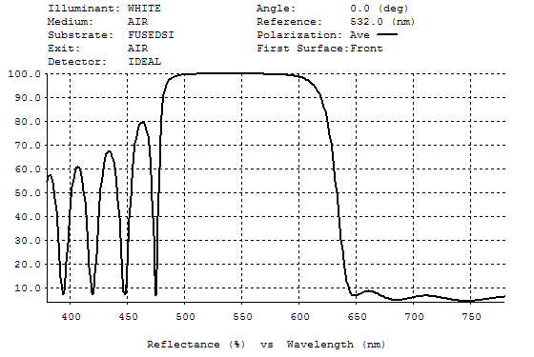
Fig.12 – Desired optical profile computed using TFCalc. A ZrO₂/SiO₂ (0.5HL0.5H)¹⁰ stack formula with a flattened band response from 650nm onwards. This type of film is known as an ‘edge filter’.

The layer thicknesses provided by TFCalc that achieve the desired optical profile are then transferred to a MS Excel file as shown below.

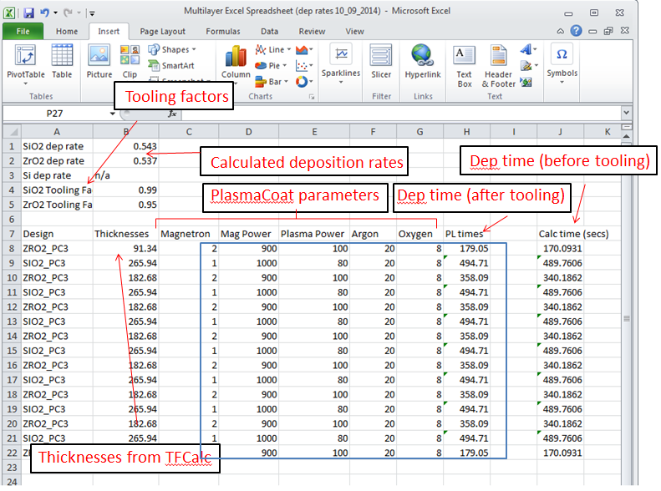
Fig.13 – MS Excel table. The information inside the blue box is copied into the text file and programmed into the PlasmaCoat.

The thicknesses provided by TFCalc are divided by the deposition rate to give the deposition times before tooling. The tooling factor will be discussed in the next section. The example in figure 13 is for a (0.5HL0.5H)⁷ edge filter centred at 1550 nm.

- Tooling Factor
Upon analysis of a deposited film it may appear that the coating does not exhibit the same optical profile as that of the design. This may be due to a number of reasons, one of which includes the fact that the system may have a factor programmed into it to automatically account for the changing deposition rates. If the machine is not calibrated correctly when new targets have been installed we must account for this factor by introducing our own tooling factor. The tooling factor may be different for the different targets. To determine the tooling factor for one material, say ZrO₂, a known thickness is deposited – any thickness can be chosen. In previous work a 3 quarter-wave optical thickness layer of zirconia centred at a wavelength of 550 nm was deposited. This provided a thickness of 190.95 nm, so using the deposition rate for zirconia, the time was found and programmed into the PlasmaCoat.

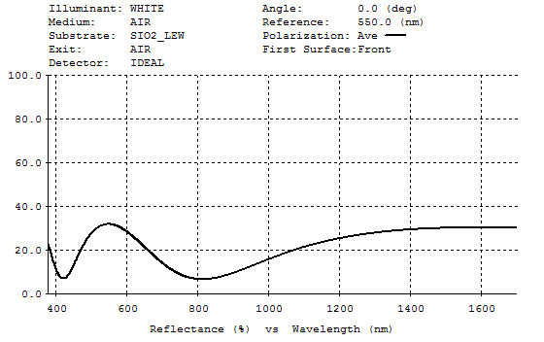
Fig.14 – Theoretical prediction for a 3 quarter-wave optical thickness layer of zirconia centred at a wavelength of 550 nm

The sample is then analysed on the spectrophotometer. If the measured results differ from the theoretical prediction, this means the tooling factor is to be corrected. This is done by taking the R & T raw data of the measured sample and importing this as ‘discrete targets’ on TFCalc – figure 15 shows what will be seen.

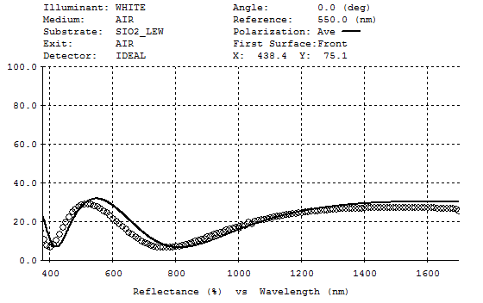
Fig.15 – Experimental results (circles) superimposed over the theoretical prediction (black line). Adjusting the group factor to align the curves gives us the tooling factor.

We can use TFCalc’s interactive analysis window in the Run menu and select the group factor from the ‘vary’ drop down menu to alter the thickness of the theoretical prediction. By altering the thickness to align the theoretical result with the experimental, we obtain the tooling factor, which we include in the MS Excel file to divide the calculated times by in order to deposit the correct prediction. In figure 15 we must reduce the thickness of the prediction by making the group factor 0.94. This means we divide the deposition times before tooling by 0.94, ultimately increasing the deposition times and therefore the layer thicknesses.
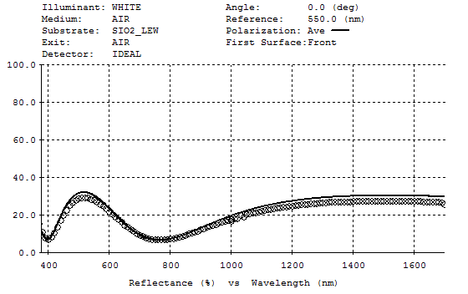
Fig.16 – Group factor altered to match theory and experiment.

If the raw data from the tooled deposition is imported into the TFCalc design, figure 16 depicts the resulting curves – theory and experiment have been matched, indicating that the PlasmaCoat has deposited the desired optical profile. The process is then repeated for SiO₂, however, the lower index layer must be deposited over the high index layer as the system automatically uses the high index layer tooling factor for the first layer deposited as the vast majority of thin film optical filters begin with a high index layer.

- Arcing
A disadvantage of the reactive gas sputtering process in a DC plasma is that the gas also reacts with the target surface (for example, if the reactive gas is oxygen and the target silicon) to form an oxide layer ‘skin’, particularly on those parts of the target outside the racetrack where ion bombardment is lowest. This insulating layer may be considered as a capacitor, with the target surface cathode acting as one electrode (negative) and the so called ‘sheath’ layer, an electron deficient plasma layer acting as a positive potential. The most energetic electrons of the Fermi-Dirac distribution are able to overcome the capacitive potential barrier which results in a capacitor discharge - as a side effect material located between the dense plasma and the cathode may undergo a phase transformation into the liquid phase. Due to the high plasma pressure, the liquid is ejected as “macroparticles” at a small angle and become deposited on the substrate. This is undesirable as it ruins film uniformity and has a detrimental effect on the films optical performance. The discharge is known as arcing and can cause severe damage to simple power supplies. In extreme cases, when the conditions are such that the oxide layer extends to the whole target surface, the result can be target poisoning and very low rates, or even no deposition. This effect is particularly pronounced with the silicon target used in the PlasmaCoat. The number of arcs occurring during a deposition show up in live time on the system status screen but the figure does not automatically reset. When starting a new run one can scroll down and highlight ‘arcing’ and then double tap enter on the keyboard to reset the number to zero.
If highly oxygenated films are required, one can alter the PlasmaCoat parameters to avoid target poisoning. One method might include reducing the oxygen flow whilst simultaneously reducing the magnetron power such that less oxygen is present to poison the targets, but the rate of metal deposition is also reduced. This will provide a sufficiently oxygenated film without the risk of arcing.

- Summary
The PlasmaCoat is a relatively simple system and has no sophisticated in-situ thickness measuring devices, nor does it have active anti-arcing power supplies or control of reactive gas partial pressure, as found on the Microdyn system in the Thin Film Centre. It must therefore be maintained in a very clean condition and continual adjustments to oxygen flow rates and deposition rates have to be made. Nevertheless, it has been proven that very good filters with in excess of 60 layers can be manufactured on this system. It is important to note that sections 4 to 7 must be repeated each time the user changes the PlasmaCoat parameters.

- References

[1] - Fleming, L. (2014). Investigation Into Plasma-Assisted DC Magnetron Sputtering Of Thin Film Metal Oxides. Physics Honours Project Report. , 4.

[2] - Unkown. (2013). Technology. Available: http://clearmetalsinc.com/technology/. Last accessed 15th Apr 2014.

[3] - Gibson, D. Martin, J. Placido, F. Child, D.. (2012). Magnetron Sputtering System for Small Batch High Throughput Production.Society of Vacuum Coaters - 55th Annual Technical Conference Proceedings, Santa Clara, CA. 1 (1), 1.

APPENDIX A

Commonly used PlasmaCoat parameters

Silicon dioxide (SiO₂)
Specialist Optics |  | Standard Opthalmic
Magnetron Power [W] | 1000 | 1000
Plasma Power [W] | 80 | 80
Argon Flow (sccm⁻¹) | 20 | 12
Oxygen Flow (sccm⁻¹) | 8 | 8

Table A – PlasmaCoat parameters for SiO₂

Zirconium dioxide (ZrO₂)
Specialist Optics |  | Standard Opthalmic
Magnetron Power [W] | 900 | 900
Plasma Power [W] | 100 | 80
Argon Flow (sccm⁻¹) | 17 | 24
Oxygen Flow (sccm⁻¹) | 8 | 6

Table B - PlasmaCoat parameters for ZrO₂

APPENDIX B

Log Book & Naming Runs
When depositing a film on the PlasmaCoat, each run should be recorded and labelled. Each run is labelled in the following way;

P-YY-M(letter)-DD-TIME

So for example, if a run is started at 1 o’clock on Monday the 22nd of August 2014, the deposition is recorded in the log book as;

P14H221300

Where the number of the month corresponds to the same number of letter from the beginning of the alphabet;
01 – January – A
02 – Febuary – B
03 – March – C
Etc.

General comments such as deposition time or number of arcs occurred can be made next to the label if the user thinks there is any extra necessary or relevant information.

